Palm Springs Unified School District
Dr. Mike Swize, Superintendent

Parent / Student Handbook
Information & Code of Conduct
2023-2024
Rancho Mirage Elementary School
42-985 Indian Trail ⧫ Rancho Mirage, CA 92270
Office (760) 836-3680 ⧫ FAX (760) 836-3684
Office Hours: 7:00 a.m. – 3:30 p.m.
Mr. J. Shane Hagar, Principal

Mission:
As a professional learning community, we at Rancho Mirage Elementary School will work collectively to provide a safe school environment that embraces diversity and ensures that all students meet/exceed the California State Standards and exhibit their personal best as we prepare them to be college and career ready, and productive citizens of society.

Bell Schedule:

TK, Kindergarten – 5th Grade

First Bell rings at 7:35 am  Second Bell rings at 7:40 am | Students need to be in line, ready for school to begin.
Class Begins at 7:45 am | Students will be in class ready for instruction.
School Ends at 2:35 pm | All students will exit through the parking lot gates on the upper playground.
School Ends at 1:00 pm | PreK SDC and Bus students will exit through the administration gate.
Minimum Days 7:45 a.m. – 12:10 p.m. | TK – 5th Grade.
- The playground gates open at 7:15 am. Please do not drop your child off before 7:15 a.m. or pick them up after 2:50 p.m., as there is no supervision.

- Students will be escorted to the upper playground for pick-up. Please do not ask your child to go to other areas for pick-up. Please use the circle drive to pick your child up (not the bus zone or outer curb). If you want to leave your car to meet your child, please park and walk to the pick-up gate. Please do not call your child to go unescorted to the parking lot or outer curb for safety reasons. The circle drive is for loading and unloading only.

Attendance
Your child must be on time and in class every day. Please help your child understand the importance of attending and getting to school on time. Students coming into class late or leaving early miss out on important instruction and may cause unnecessary distractions as the lessons are underway.

If your child is absent, please call the office at (760) 836-3680 to inform us of the reason. Some missed classwork might be made up, but most of your child’s education is direct instruction by the teacher. They will miss it if they are not present.

If your child must leave school before 2:35 pm, please go to the office and sign your child out. Identification is required. Please do not pick your child up 15 minutes before the dismissal bell because teachers assign enrichment work and finalize the instructional day. The secretary will contact the teacher and have him/her sent to the office. Teachers may only release a student to someone if they have been signed out in the office and are on the emergency card. Please keep your address, telephone number, and emergency contact information current. If your child rides the bus, and you want to pick him/her up on a particular day, please let your child know before school and send a note to the teacher or call early enough that we can inform the child’s teacher.

SARB – School Attendance and Review Board
Every school day counts! Studies show that students who miss 10% of their school day need to catch up in grade-level preparedness. If your child is habitually absent and/or tardy, you and your child will be referred to the District’s School Attendance Review Board. Your child must come to school each day on time. Attendance incentive programs and award assemblies will be held weekly and monthly to promote positive student growth in the attendance rate.

Independent Study
If your child must be absent for more than 5 days, you may enroll them in Independent Study. This requires that you get assignments from your child’s teacher, have the teacher complete a written agreement with the Independent Study Program, have your child complete the assignments, return the assignments to the teacher, and have the teacher verify their completion of the Independent Program agreement. Please give the teacher at least a week’s notice to allow him/her to complete the required paperwork.

Breakfast and Lunch
Breakfast is served daily in our cafeteria from 7:15 am- 7:35 a.m. Breakfast and Lunch are free for all students. Each is served daily. We ask that you fill out the Educational Benefits Form for Nutrition Services. You will receive information on how to do so on the school and district websites. Some families may be randomly chosen to complete district informational surveys for nutrition services.

Messages
We understand that there may be a time when you must get a message to your child during the school day, but please limit these to emergencies. To avoid interruptions to classroom instruction, messages will be taken and distributed to the teacher directly via email, phone call, or written message. Please tell your child and write a note to the teacher if there will be a change in the procedure for how your child gets home.

Emergency Procedures
All students will be evacuated to the playground in an earthquake or other disaster. You will pick up your child at the designated reunification area. You must sign your child out, depending on the circumstances. Your child will receive care and shelter if you cannot reach the school. Schools will remain open indefinitely until every child has been released to a parent or authorized person or transported to an emergency center. Students will only be released to persons listed on their emergency cards, so please keep it current. The administration will distribute emergency preparedness protocols on back-to-school night. Please discuss emergency plans with your child.

Cell phones
Cell phone use at elementary schools is against Board Policy. Please try not to send a phone to school with your child. If the phone is used during the school day, it will be taken away and sent to the office. The first time a phone is taken, the student can pick it up in the office after school, and parents will be contacted. If a phone is confiscated more than once, parents must come to the office to pick them up.

School Rules
To ensure a safe and orderly environment for your child and all of the children at Rancho Mirage School, the following rules must be followed by all students at all times.

Be kind and thoughtful!
- Keep hands, feet, and unkind words to yourself.
- Take care of yourself, others, and our school.
- Keep our campus clean.

Be safe and smart!
- All balls, toys, and electronic items must be left at home unless the administration approves.
- Eat snacks in the area provided. No gum allowed.
- Stay on the playground during recess and play safely.
- No throwing of rocks, sticks, or other objects.
- Walk and use the sidewalks.
- NO weapons, play weapons, or dangerous objects of any kind are allowed.

Be respectful!
- Follow directions and be respectful to all adults and students
- Use quiet voices and appropriate language

Please review District Rules in the District Handbook.

Be a Respectful RamStar! Follow the rules and be recognized with Ramhorns and other awards.
- Low & High-Level offenses can lead to receiving a referral. These are due to needing to follow school rules.

Playground Procedures
- Students will wash their hands before and after recess
- At the 5-minute whistle (five short whistles) this is time to put balls away, get drinks, and go to the bathroom.
- When the whistle is blown once, stop, freeze, and listen.
- Walk to line quietly when directed.
- Students will “Stay in their lane” when returning to class.

Pyramid of Success
Coach Wooden’s Pyramid of Success is a cornerstone of our school character education initiative and gives students the tools they need to be their personal best. Every month we celebrate a chosen building block of the pyramid as a school. A copy of the pyramid will go home at the beginning of the school year for parents to use. We encourage you to talk to your child about the character of each block and have an incentive for them to exhibit their personal best at home.

Kindness Counts – Kindness costs nothing, but it means everything.
Students will be reminded to show kindness to one another by always modeling kindness. The students will be given kindness tasks throughout the school year to promote an atmosphere and culture of genuine kindness.

Tobacco and Drugs
Rancho Mirage School is a tobacco and drug-free school. Students and adults are not allowed to smoke or be under the influence of drugs when on campus. Students and adults may not possess, use, or sell drugs or alcohol. Students will be suspended and possibly expelled according to the Education Code.

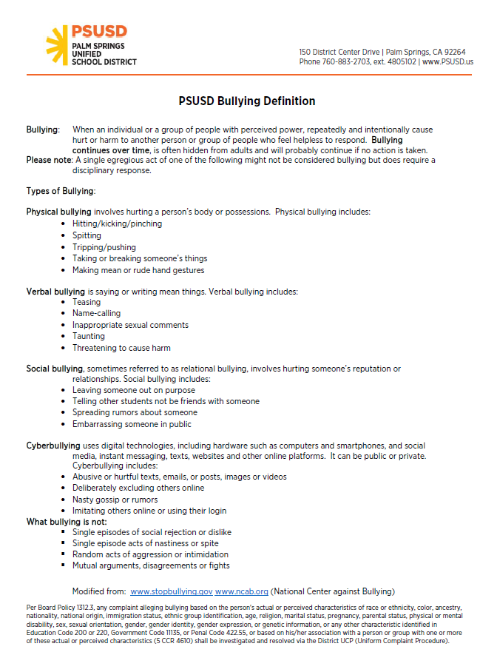

Suspensions

Out of School Suspensions
The most common reasons for suspension are fighting and physical aggression in and out of class. However, if a knife, gun, or dangerous object is brought to school, these are grounds for suspension and possible expulsion. This is also true of an imitation firearm if it looks like a real weapon. Laser pointers are forbidden on campus under Penal Code 417.27. Beginning in 4th grade, students may be suspended for sexual harassment. See PSUSD Handbook for more information on suspensions and sexual harassment.

Acts for which a student, including a student with disabilities, may be suspended or expelled shall be only those specified as follows:
1. Caused, attempted to cause, or threatened to cause physical injury to another person; willfully used force or violence upon another person, except in self-defense; or committed as an aider or abettor, as adjudged by a juvenile court, a crime of physical violence in which the victim suffered a great or serious bodily injury (Education Code 48900(a) and (t))
2. Possessed, sold, or otherwise furnished any firearm, knife, explosive, or other dangerous objects unless, in the case of possession of any object of this type, the student had obtained written permission to possess the item from a certificated school employee, with the principal or designee's concurrence (Education Code 48900(b))
3. Unlawfully possessed, used, sold, otherwise furnished, or was under the influence of any controlled substance as defined in Health and Safety Code 11053-11058, alcoholic beverage, or intoxicant of any kind (Education Code 48900(c))

4. Unlawfully offered, arranged, or negotiated to sell any controlled substance as defined in Health and Safety Code 11053-11058, alcoholic beverage, or intoxicant of any kind, and then sold, delivered, or otherwise furnished to any person another liquid, substance, or material and represented same as a such controlled substance, alcoholic beverage, or intoxicant (Education Code 48900(d))

5. Committed or attempted to commit robbery or extortion (Education Code 48900(e))
6. Caused or attempted to cause damage to school property or private property (Education Code 48900(f))
7. Stole or attempted to steal school property or private property (Education Code 48900(g))
8. Possessed or used tobacco or products containing tobacco or nicotine products, including, but not limited to, cigars, cigarettes, miniature cigars, clove cigarettes, smokeless tobacco, snuff, chew packets, and betel, except that this restriction shall not prohibit a student from using or possessing his/her own prescription products (Education Code 48900(h))
9. Committed an obscene act or engaged in habitual profanity or vulgarity (Education Code 48900(i))
10. Unlawfully possessed, offered, arranged, or negotiated to sell any drug paraphernalia, as defined in Health and Safety Code 11014.5 (Education Code 48900(j))
11. Knowingly received stolen school property or private property (Education Code 48900(l))
12. Possessed an imitation firearm (Education Code 48900(m))
Imitation firearm means a replica of a firearm that is so substantially similar in physical properties to an existing firearm as to lead a reasonable person to conclude that the replica is a firearm. (Education Code 48900(m))
13. Committed or attempted to commit a sexual assault as defined in Penal Code 261, 266c, 286, 288, 288a, or 289, or committed a sexual battery as defined in Penal Code 243.4 (Education Code 48900(n))
14. Harassed, threatened, or intimidated a student who is a complaining witness or witness in a school disciplinary proceeding to prevent that student from being a witness and/or retaliating against that student for being a witness (Education Code 48900(o))
15. Unlawfully offered, arranged to sell, negotiated to sell or sold the prescription drug Soma (Education Code 48900(p))
16. Engaged in, or attempted to engage in, hazing (Education Code 48900(q))
Hazing means a method of initiation or pre-initiation into a student organization or body, whether or not the organization or body is officially recognized by an educational institution, which is likely to cause serious bodily injury or personal degradation or disgrace resulting in physical or mental harm to a former, current, or prospective student. Hazing does not include athletic events or school-sanctioned events. (Education Code 48900(q))
17. Engaged in the act of bullying (Education Code 48900(r))
Bullying means any severe or pervasive physical or verbal act or conduct, including communications made in writing or using an electronic act, directed toward one or more students that have or can reasonably be predicted to have the effect of placing a reasonable student in fear of harm to himself/herself or his/her property; cause the student to experience a substantially detrimental effect on his/her physical or mental health; or cause the student to experience substantial interferences with his/her academic performance or ability to participate in or benefit from the services, activities, or privileges provided by a school. (Education Code 48900(r))
Bullying shall include any act of sexual harassment, hate violence, or harassment, threat, or intimidation, as defined in Education Code 48900.2, 48900.3, or 48900.4 and below in items #1-3 of "Additional Grounds for Suspension and Expulsion: Grades 4-12," that has any of the effects described above on a reasonable student.
Bullying also includes an act of cybersexual bullying by a student through the dissemination of, or the solicitation or incitement to disseminate, a photograph or other visual recording that depicts a nude, semi-nude, or sexually explicit photograph or other visual recordings of an identifiable minor, when such dissemination is to another student or school personnel using an electronic act and has or can be reasonably predicted to have one or more of the effects of bullying described above. Cybersexual bullying does not include a depiction, portrayal, or image with any serious literary, artistic, educational, political, or scientific value or involving athletic events or school-sanctioned activities.
Electronic act means the creation or transmission of communication originated on or off the school site, including, but not limited to, a message, text, sound, image, or post on a social network Internet website, using an electronic device, including, but not limited to, a telephone, wireless telephone, or other wireless communication devices, computer, or pager. A post on a social network Internet website shall include but is not limited to, the posting or creation of a burn page or a credible impersonation or false profile to cause a reasonable student any of the effects of bullying described above. (Education Code 48900(r))
Reasonable student means a student, including, but not limited to, a student who has been identified as a student with a disability, who exercises average care, skill, and judgment in conduct for a person of his/her age or for a person of his/her age with his/her disability. (Education Code 48900(r))
18. Aided or abetted the infliction or attempted infliction of physical injury on another person, as defined in Penal Code 31 (Education Code 48900(t))
19. Made terrorist threats against school officials and/or school property (Education Code 48900.7)
A terrorist threat includes any written or oral statement by a person who willfully threatens to commit a crime that will result in death or great bodily injury to another person or property damage over $1,000, with the specific intent that the statement is to be taken as a threat, even if there is no intent of actually carrying it out. (Education Code 48900.7)
Additional Grounds for Suspension and Expulsion: Grades 4-12
Any student in grades 4-12 may be suspended, but not expelled, for disrupting school activities or otherwise willfully defying the valid authority of supervisors, teachers, administrators, other school officials, or other school personnel engaged in the performance of their duties. (Education Code 48900(k))
A student in grades 4-12 shall be subject to suspension or recommendation for expulsion when it is determined that he/she:
1. Committed sexual harassment as defined in Education Code 212.5 (Education Code 48900.2)
Sexual harassment means conduct which, when considered from the perspective of a reasonable person of the same gender as the victim, is sufficiently severe or pervasive as to hurt the victim's academic performance or to create an intimidating, hostile, or offensive educational environment. (Education Code 212.5, 48900.2)
(cf. 5145.7 - Sexual Harassment)
2. Caused, attempted to cause, threatened to cause, or participated in the act of hate violence as defined in Education Code 233 (Education Code 48900.3)
Hate violence means any act punishable under Penal Code 422.6, 422.7, or 422.75. Such acts include injuring or intimidating a victim, interfering with the exercise of a victim's civil rights, or damaging a victim's property because of the victim's race, ethnicity, religion, nationality, disability, gender, gender identity, gender expression, or sexual orientation; a perception of the presence of any of those characteristics in the victim; or the victim's association with a person or group with one or more of those actual or perceived characteristics. (Education Code 233; Penal Code 422.55)
(cf. 5145.9 - Hate-Motivated Behavior)
3. Intentionally engaged in harassment, threats, or intimidation against district personnel or students that is sufficiently severe or pervasive to have the actual and reasonably expected effect of materially disrupting class work, creating substantial disorder, and invading the rights of school personnel or students by creating an intimidating or hostile educational environment (Education Code 48900.4)
No student in grades K-3 may be suspended for disruption or willful defiance except by a teacher under Education Code 48910. (Education Code 48900)

In-School Suspensions
Teachers may suspend students from their classes for up to 2 days. The teacher will notify the parent. According to Education Code 48900.1, the administration may request the parent to attend an entire school day as an alternative to suspension.

Sexual Harassment
The Board of Education is committed to maintaining an environment free from harassment and discrimination. The Board prohibits sexual harassment of students by other students, employees, or other persons at school or at school-sponsored or school-related activities. The Board also prohibits retaliatory behavior or action against persons who complain, testify, assist, or otherwise participate in the complaint process established under this policy and the administrative regulation.
The Board strongly encourages any student who feels that he/she is being or has been sexually harassed on school grounds or at school-sponsored or school-related activities or who has experienced off-campus sexual harassment that has a continuing effect on campus, to immediately contact his/her teacher, the principal, or any other available school employee.
The Board is committed to complying with Title IX of the Education Amendments of 1972 (Title IX), 20 U.S.C. 1681 et seq., and it's implementing regulations prohibiting discrimination based on sex in education programs or activities operated by federal financial assistance recipients. Sexual harassment, including sexual violence, is a form of sex discrimination prohibited by Title IX.
The Coordinator or designee shall ensure that all district students receive age-appropriate instruction and information on sexual harassment. Such instruction and information shall include the following:
1. What acts and behavior constitute sexual harassment, including the fact that sexual harassment could occur between people of the same gender
2. A clear message that students do not have to endure sexual harassment
3. Encouragement to report observed instances of sexual harassment, even where the victim of the harassment has not complained
4. A clear message that student safety is the district's primary concern and that any separate rule violation involving an alleged victim or any other person reporting a sexual harassment incident will be addressed separately and will not affect how the sexual harassment complaint will be received, investigated, or resolved
5. Information about the district's procedure for investigating complaints and the person(s) to whom a report of sexual harassment should be made
6. Information about the rights of students and parents/guardians to file a civil or criminal complaint, as applicable
7. A clear message that, when needed, the district will take interim measures to ensure a safe school environment for a student who is the complainant or victim of sexual harassment and/or other students during an investigation and that, to the extent possible, when such interim measures are taken, they shall not disadvantage the complainant or victim of the alleged harassment.
Complaint Process
Any student who feels that he/she is being or has been subjected to sexual harassment shall immediately contact his/her teacher or any other employee. A school employee to whom a complaint is made shall report it to the principal or the District Coordinator within one school day of receiving the complaint.
Any school employee who observes any incident of sexual harassment involving a student shall take immediate steps to intervene when safe to do so and report this observation to the Coordinator, whether or not the victim files a complaint.
In any case of sexual harassment involving the Coordinator or any other district employee to whom the complaint would ordinarily be made, the employee who receives the student's report or who observes the incident shall report to the Superintendent.
District Title IX Coordinator: Joe Scudder
Asst. Supt. of Educational Services or Designee
150 District Center Drive
Palm Springs, CA 92264
760-883-2703, ext. 4805002
Regardless of whether the student files a complaint, the Coordinator or designee shall contact the student (or parent, depending on the student's age) and explain that the district is responsible for investigating the allegation of sexual harassment and taking corrective action, and explain the informal and formal procedures for filing a complaint, including how the procedures work.
Upon receiving the complaint, the Coordinator or designee shall immediately initiate the complaint investigation procedures by AR 1312.3 - Uniform Complaint Procedures. Where the Coordinator or designee finds that sexual harassment occurred, he/she shall take prompt, appropriate, effective action to end the harassment and address its effects on the victim. The Coordinator or designee shall also advise the victim of any other remedies that may be available and take steps to prevent further harassment. The Coordinator or designee shall file a report with the Superintendent or designee and refer the matter to law enforcement authorities, where required.
Disciplinary Measures
Any student who engages in sexual harassment of anyone at school or a school-sponsored or school-related activity violates this policy and shall be subject to disciplinary action. For students in grades 4 through 12, disciplinary action may include suspension and/or expulsion, provided that in imposing such discipline, the entire circumstances of the incident(s) shall be considered.
Response Pending Investigation
When an incident of sexual harassment is reported, the principal or designee, in consultation with the Coordinator, shall determine whether interim measures are necessary pending the investigation results. Such measures shall be those necessary to stop the harassment, if still ongoing, and to ensure a safe school environment for a student who is the complainant or victim of sexual harassment and/or other students during an investigation. To the extent possible, when such interim measures are taken, they shall not disadvantage the complainant or victim of the alleged harassment.
All complaints and allegations of sexual harassment shall be kept confidential except as necessary to carry out the investigation or take other subsequent necessary action. The Coordinator or designee will discuss confidentiality standards with the student when the complaint is initiated.

Volunteers
We encourage parent participation at Rancho Mirage Elementary School. The district office must clear all volunteers before volunteering at the school. This requirement also includes volunteering in the classroom, around campus, chaperoning field trips, etc. All persons volunteering can go to www.psusd.us for more information on how to be cleared or call the school office. Once cleared, school policy is that there is a 72-hour request, as we will need approval from the classroom teacher and/or administration. Volunteers are on an “as-needed basis.”

Observations
Our policy for classroom observations is that we receive a 72-hour request. We will need to make arrangements with the classroom teacher and arrange for an administrator to escort the observer into the classroom. Classroom observations are 30 minutes at maximum, once monthly.

RM-PTG
Parents can get involved at Rancho Mirage School by attending the RM-PTG meetings. This group of parents and school staff supports the school by volunteering their time and raising money. Watch for Parent Square and Marquee messages regarding dates and meeting times.

School Site Council / English Learners Advisory Committee/Title I
Parents are encouraged to attend the School Site Council, English Learner Advisory Committee meetings, Title I Parent meetings, and training. These groups guide our school plan and help assess the school's needs. Officers are elected by their peers on a two-year basis. We encourage all parents to join us. Your input is important to us. Please refer to the calendar, Parent Square, and other notices regarding dates and times for these meetings. SSC/ELAC = School Site Council/English Learners Advisory Committee

Communication Hub and Parent Square
The best way to track what is happening at RMES is through our online communication platform, “Parent Square.” Also, our communication hub includes upcoming activities, a message from the principal, and school news. The communication hub is posted on our website.

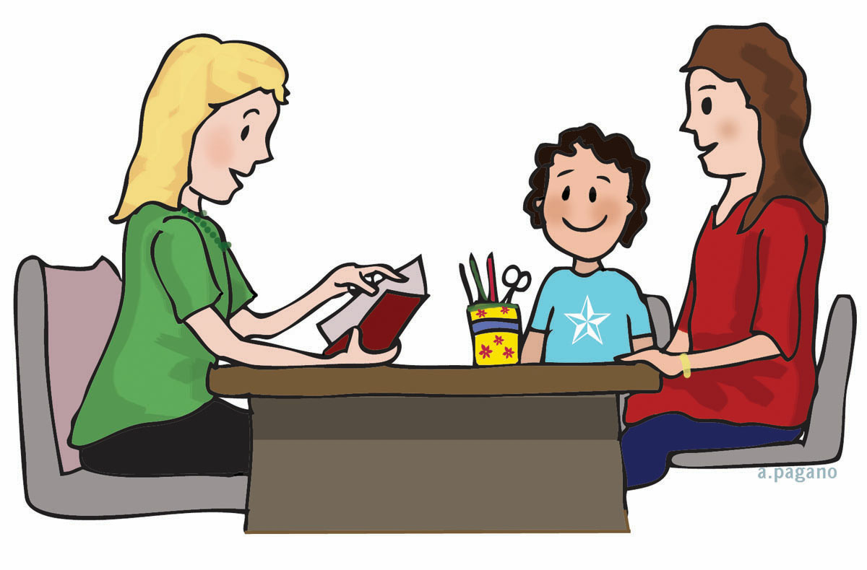

Report Cards and Conferences
Report cards are issued in November, March, and June. Standard-based report cards will measure your child’s progress toward the California State Standards. Conferences are held in November and March. We encourage every parent to make time for these important meetings. Additional meetings can be scheduled between the parent and teacher as needed. Please contact your child’s teacher if you have concerns throughout the year.

California Assessment of Student Performance & Programs (CAASPP)
California State Standards Tests are given to third through fifth graders in the spring of each year. These tests measure how well your child has learned the material taught that year. The results are released at the beginning of the following school year. These results help us to guide your child’s learning for the following year. The students' results are combined to measure the school as a whole against targets set for us. If you have any questions regarding your child’s or the school’s performance, please contact your child’s teacher or the principal.

GATE Testing (Gifted and Talented Education)
In March, testing is administered to Gr. 2-4 by a teacher or parent referral only. This exam, in addition to classroom performance, parent and teacher surveys, and additional scores, is used to qualify students for the GATE classes for the following year.

ELPAC Testing (English Language Proficiency Assessment for California)
All students that speak a language other than English or are spoken to in a language other than English, as indicated by the Home Language Survey, will be tested each year until they demonstrate proficiency on the ELPAC assessment and classroom performance tests. This is a state-required test, formerly CELDT.

Uniforms
Rancho Mirage is a uniform school. We appreciate your support in ensuring your children are in uniform daily.

Shirts and Blouses
- Blue or White with a collar – Not “T” shirts, except Rancho Mirage Shirts
- White turtleneck
Slacks/Shorts/Skorts/Skirts/Dresses/Jumpers
- Navy Blue or Khaki Pants
- Pants and shorts are to be worn no more than one size larger than the student’s appropriate size.
- Navy Blue or Khaki skirts, jumpers, and skorts
- If a belt is worn, it is to be an appropriate length.
- All shorts and skirts need to be an appropriate length.
- Jeans can be worn on Fridays
Sweaters/Jackets/Sweatshirts/Coats
- Navy Blue or White sweaters
- Navy Blue sweatshirts with no lettering
Shoes
- Shoes must be worn at all times.
- For the safety of your child, please no sandals or backless shoes.
Hats and Sunglasses
- Hats must be worn facing forward.
- No inappropriate logos that would cause a disturbance may be on the hat or cap.
- Sunglasses may be worn outside only.
School Uniform and Spirit Wear
- School shirts will continue to be sold by our PTG
- School spirit wear can also be purchased online and directly shipped to your house using our spirit wear website: www.ranchomiragespiritwear.com

For information on Dress Code, please refer to the PSUSD Student Handbook.

- If you cannot afford uniforms for your children, please contact Yolanda in the office. We will do everything we can to provide your children with uniforms.

Student Wellness
The Palm Springs Unified School District Board of Education adopted a Board Policy for student wellness. This policy discusses nutrition and physical activity. The food served in the cafeteria at breakfast, and lunch will have new nutritional guidelines. Low-fat and fat-free milk will be served, as well as providing more whole grains. A variety of fruits and vegetables will also be served. The policy also strongly encourages parents not to bring fast food lunches to school but to provide nutritious food if they are providing food from home.

According to the policy, schools should limit celebrations that involve food during the school day to no more than one party per class per month. Each party should include foods that meet nutrition standards. For food-safety reasons, all items brought from home for class celebrations must be prepared in an approved commercial facility and pre-wrapped. Food prepared at home shall not be served in the class. Please refer to your child’s teacher for classroom guidelines regarding celebrations, including birthdays. Cookies and cupcakes are not permitted.

Please refer to the school menu for copies of the nutrition analysis of school lunches. For a copy of the Student Wellness Board Policy, go to www.psusd.us or contact the Nutrition Services Department.

Safe School Plan
An RMES committee writes 2 goals regarding the safety of our students. One goal is regarding the students, and the other addresses the environment. Each goal is followed by activities that will support the goals.

Goal #1 - Rancho Mirage Elementary School will provide an environment on the playground and in the classroom where students can demonstrate their personal best.

Goal #2 – The school safety team will identify physical hazards on campus and contact the appropriate department to make improvements.

Academic School Plan
Palm Springs Unified School District Goals:

- Attendance
The ultimate attendance goal in the Palm Springs Unified School District is for all students to attend school every day. There is a definite link between attendance and academic achievement. In addition, the district is significantly fiscally impacted as attendance increases or decreases. All elementary schools will have at least 96% attendance rates, and all middle and high schools will have at least 95% attendance rates.

- Reading /Language Arts/Math/Science/Social Studies
All Palm Springs Unified School District students will meet grade level proficiency or above in the standards in the core academic subjects as measured by the annual CAASPP testing.

- English Language Learners
All English Language Learners in the Palm Springs Unified School District will advance one level per year in English language proficiency as measured by annual state testing (ELPAC).
Parent Student Handbook
2023-2024
Please return to your child’s teacher by September 1, 2023

Parents,

Please help your child think of a goal they would like to reach by the first of November. It can be a behavioral goal or an academic goal. Then list 3 things that your child (with your assistance and support) can do to help him/her reach this goal. The teachers will review this at Back to School Night, so if you need help completing this form with your child, please wait until then to set the goal.

Student Goal: My goal for this trimester is to _______________________

To achieve my goal, I will:

- ______________________________________________________________________________________________________

- ______________________________________________________________________________________________________

- ______________________________________________________________________________________________________

My child, (student name) ______________________, and I have read and reviewed the Parent Student Handbook and agree to work on this goal.

Student’s signature: __________________________

Parent signature: ____________________________

Date: ________________

Teacher: __________________________ Rm #: __________

